Debrick Procedure for Ubiquti Powerbeam 400

0.1 | 27/06/2016 | A.Vania
Rev. | Date | Edited:
Revision History
Rev. | Data | Descrizione | Edited:
0.1 | 27/06/2016 | First Issue | A.Vania

Annexes
Document Code | Rev. | Date | Document Title
N.A. | N.A. | N.A. | N.A.
Index
1 Introduction 5
1.1 Purpose of the document 5
1.2 Starting scenario 5
2 Remote reset procedure 6
3 Open the antenna 7
4 Connection to serial port 9
5 Backup of cfg and ART partitions 11
6 Defining new partitions 12
7 Restoring ART and cfg partitions 13
8 Closing the antenna into the case 14

Figures Index
Fig. 1: reset board for remote reset button 6
Fig. 2: cutting of Powerbeam400 plastic case with DREMEL tool 7
Fig. 3: PowerBeam400 opened 8
Fig. 4: contacts header for serial connection 9
Fig. 5: connection of serial interface 10
Fig. 6: epoxy resin used to close the antenna 16
Fig. 7: preparation of the surfaced to be glued 17
Fig. 8: disposal of fiberglass band 17
Fig. 9: antenna closed and glued 18

Introduction

Purpose of the document
The purpose of this document is to provide a guide to debrick the Ubiquiti Powerbeam400 Equipment if an error occurs during the original FW or third party upload.

Starting scenario
In my case, the antenna was bricked because I didn’t know about the partition change from AirOS 5.6.
The issue is described in the following link: http://www.aredn.org/content/ubiquiti-airos-56-alert-0
I started to install OPEN-WRT starting from AirOS 5.6, selecting the bin image from the GUI. At the beginning, OpenWRT was working fine and I installed all the plugins that I needed and I made all the configurations. Then I rebooted and…I got again the original OPEN-WRT configuration! No Luci, no additional packets, no config..
I searched on the interned and I understood that I bricked the antenna.
At that point, I tried to put the antenna in safety mode pressing the reset button and using TFTP, but it was not successful using both AirOS 5.6 e and AirOS 5.5.
At this point I realized that I had to open the antenna and use the serial interface.

Remote reset procedure
In my case, the powerbeam was installed on a 10 meter high tower, so it was not so easy to press the reset button.
Searching on the internet, I figure out the schematic for the remote reset button, that is included in the POE-24-12W and POE-24-12W-G series of the ubiquiti power supply.
I have built the circuit reported in Figura 1: reset board for remote reset button on a prototype board.
Holding the button for 10 seconds, the device goes in maintenance mode and it’s possible to upload a FW by TFTP.
If the procedure is not successful, it could be necessary to work on serial console, so please go directly to paragraph 3.

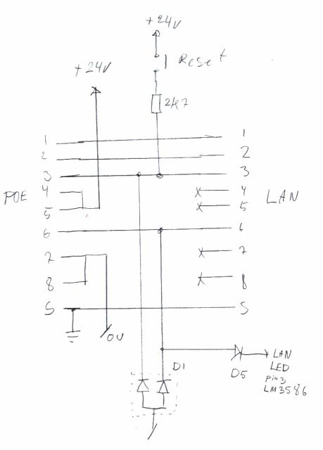
Fig. 1: reset board for remote reset button

Open the antenna
The powerbeam is a sealed device. If the serial console is needed, it’s necessary to cut the front dish with a dremel tool.
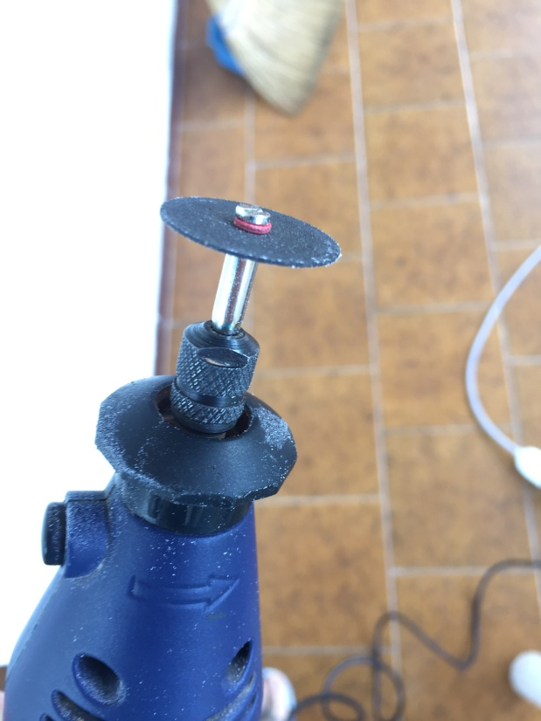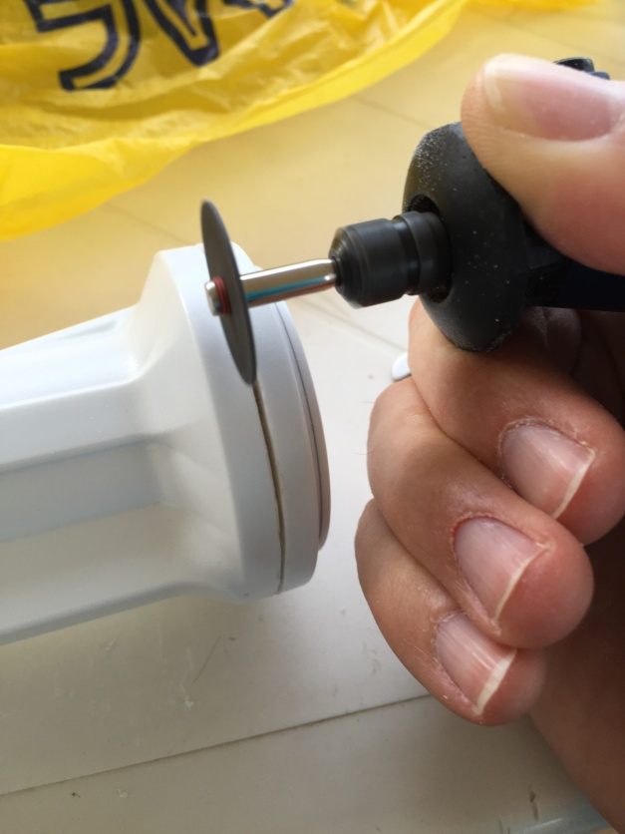
Fig. 2: cutting of Powerbeam400 plastic case with DREMEL tool

At the end of the cutting, gently remove the cup and extract the internal board:

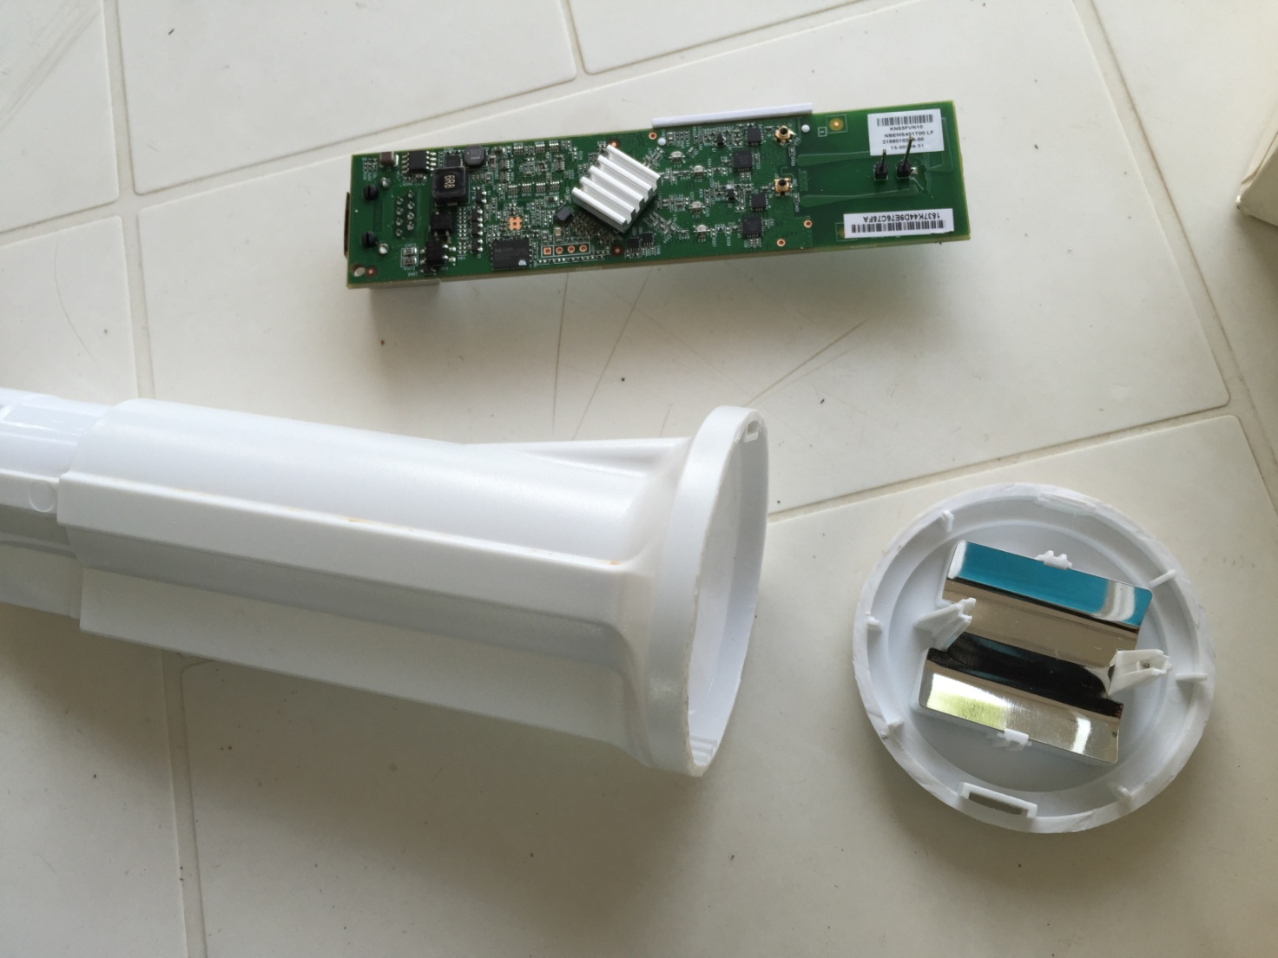
Fig. 3: PowerBeam400 opened

Connection to serial port
Despite of other ubiquity devices, the powerbeam is not equipped with the headers on the serial port.
It’s possible to solder the wires of the serial adapter directly to the PCB, otherwise it’s better to position and solder a 4-pin, 2,54mm spaced headers into the holes (refer to fig. TBD)

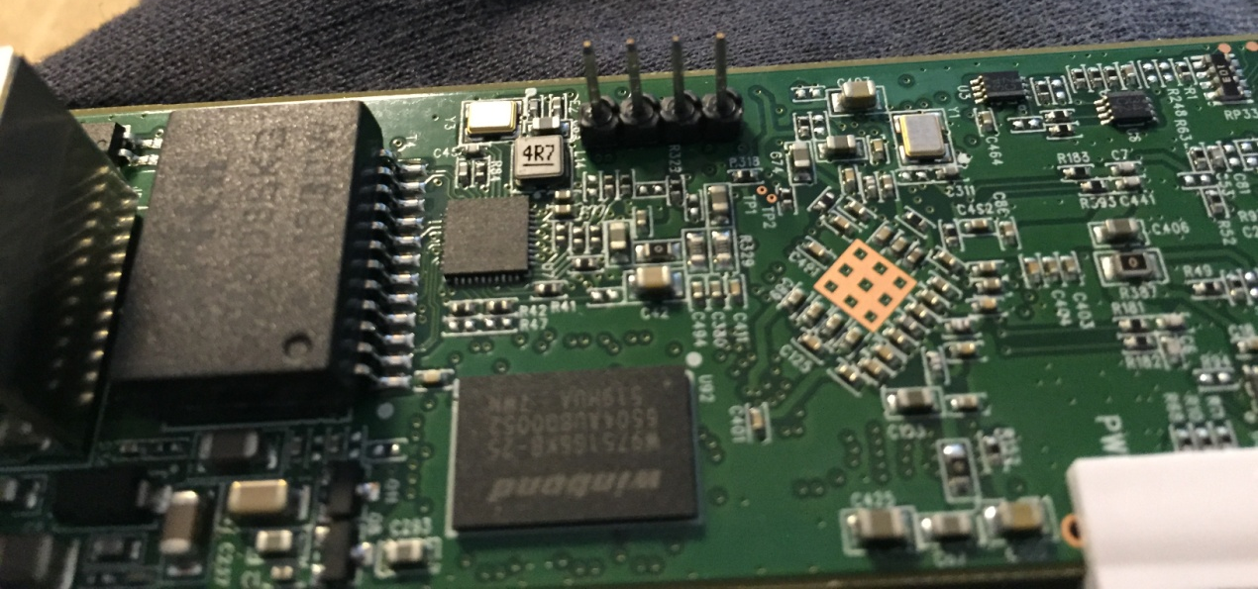
Fig. 4: contacts header for serial connection

When the headers are soldered, it’s possible to connect an USB-TTL adapter.
In my case I used a prolific PL2303 adapter, and I connected RX, TX and GND respectly to the pins 3,2,1 of the connector (ref.Fig. 5)

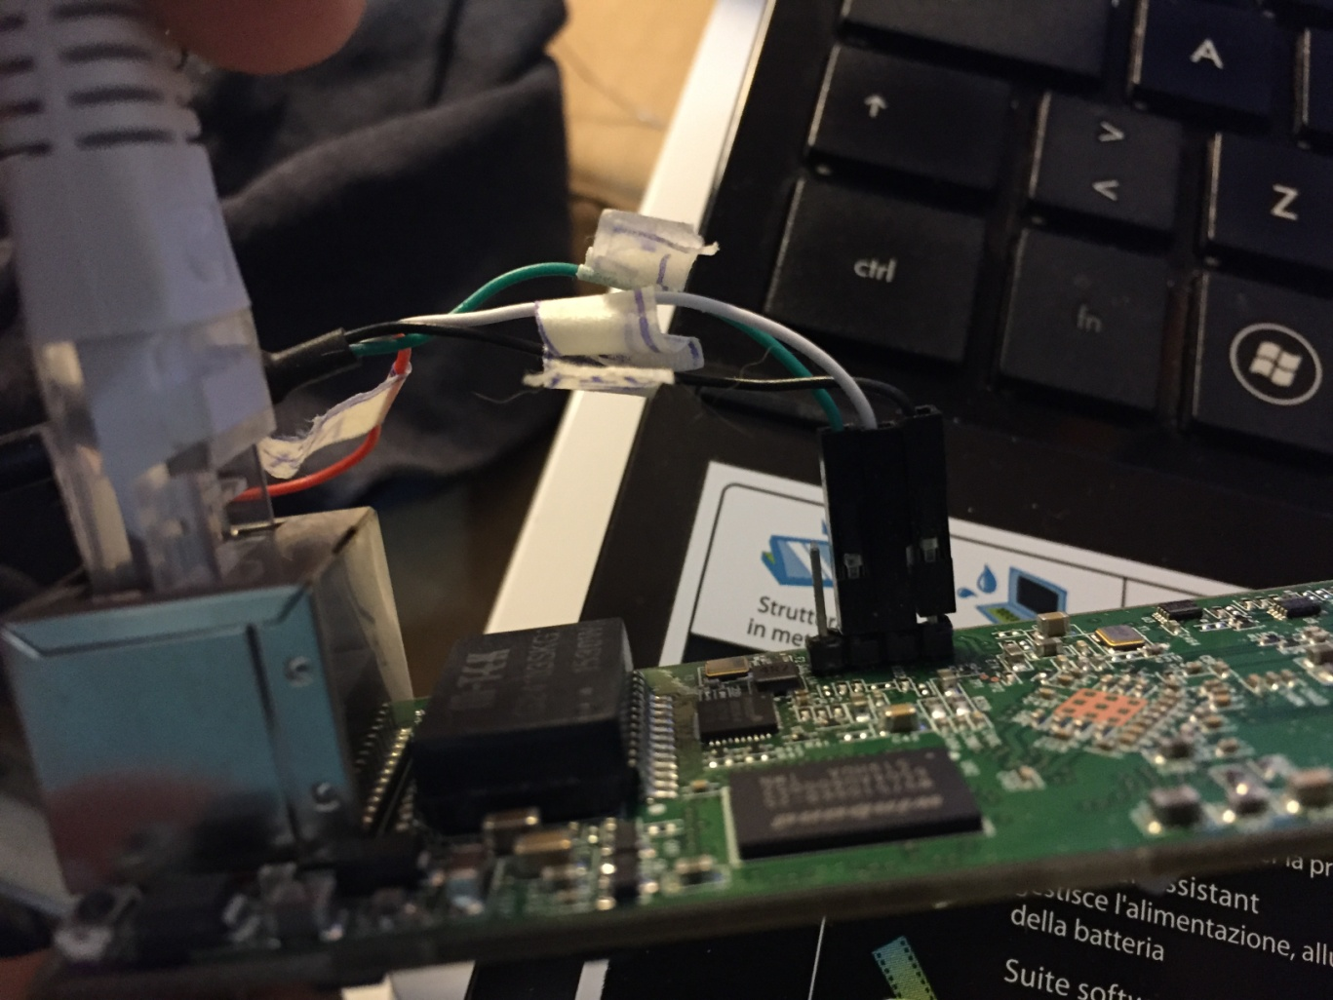
Fig. 5: connection of serial interface
When the serial adapter is connected, it’s possible to open a serial emulator console (I used RealTerm : http://realterm.sourceforge.net/ ) and open the serial port corresponding to the USB adapter with these parameters:

Speed: 115200
Parity: None
Stop: 1 bit
Flow control: None

At the boot, you can see on the serial console the following bootstrap message:

DRAM: 64 MB
Flash: 8 MB (0xc2, 0x20, 0x17)
Net: AR8035
eth0, eth1
Board: Ubiquiti Networks AR9342 board (e4e5-84255.1122.0030)
Radio: 0777:e4e5
Reset: Normal
Hit any key to stop autoboot: 1 0

Backup of cfg and ART partitions

It’s necessary to backup the partitions:
- mtd6 (cfg)
- mtd7 (EEPROM)

In my case, OPENWRT was working in safe mode, so it was possible to use “dd” command in order to do the partition dump.
Here below, the manual procedure is described. Alternatively, the AREDN utility can be used in order to do the backup of the partitions:
http://www.aredn.org/sites/default/files/sites/default/files/pictures/user-K5DLQ/AREDN%20U-Boot%20Test%20v1.1.4.0%20setup.exe

Regarding the manual procedure, from openwrt console, type the following commands:
- dd if=/dev/mtd6 of=/tmp/mtd6.backup
- dd if=/dev/mtd7 of=/tmp/mtd7.backup

Using “scp” commands, copy the backup files from /tmp folder to an external Linux PC with scp server installed (be sure sshd is installed on the PC and the config file is Ok for accepting external connections. Check the option “PermitRootLogin” is “yes”).

Keep the backup files in a safe folder until the upload phase.

Defining new partitions

At this point, the new partitions must be written into environment variables of uboot, referring to http://www.aredn.org/content/ubiquiti-airos-56-alert-0

To do this, the uboot itself must be overwritten with the correct one included in AirOS5.x .

With serial port emulator, watch the messages at the power up. A button must be pressed when uboot reaches the following point:

DRAM: 64 MB
Flash: 8 MB (0xc2, 0x20, 0x17)
Net: AR8035
eth0, eth1
Board: Ubiquiti Networks AR9342 board (e4e5-84255.1122.0030)
Radio: 0777:e4e5
Reset: Normal
Hit any key to stop autoboot: 1 0

Type: "urescue -f -e"
The device enters in safe mode and waits for tftp connection
From an external pc with TFTP server installed, load the openwrt .bin image
With the option “-f –e” the uboot partition will be overwritten (without this option, or pressing the reset button for safe mode, the boot partition will never be overwritten).

Reboot the device and stop again at the boot.
Type “mtdparts” and check that the offsets of mt6 and mtd7 are the following:

device nor0 <ar7240-nor0>, # parts = 6
#: name size offset mask_flags
0: u-boot 0x00040000 0x00000000 0
1: u-boot-env 0x00010000 0x00040000 0
2: kernel 0x00100000 0x00050000 0
3: rootfs 0x00660000 0x00150000 0
4: cfg 0x00040000 0x007b0000 0
5: EEPROM 0x00010000 0x007f0000 0

Then, the new partition table must be saved. To do this, type command “saveenv”.

Restoring ART and cfg partitions

At this point, you have openwrt working on the device, but the art and cfg partitions must be restored in order to have original wifi performance.
In order to to this:

- Install a tftp server on a linux PC (apt-get install xinetd tftpd)
- Set the ip addres of linux PC on 192.168.1.254 (this is the default server address that uboot considers)
- Put the backup files mtd6.backup and mtd7.bakup of paragraph 5 in the tftpd folder
- On uboot serial console, type tftpboot “0x80000000 mtd6.backup”. This will put the backup file in the RAM memory of the device.
- Erase the destination partition with command "erase 0x9f7f0000 +0x40000" (0x9f is the flashstart offset seen by “bdinfo” command)
- Copy the RAM content into the partition with command “cp.b 0x8000000 0x9f7b0000 0x10000”
- On uboot serial console, type tftpboot “0x80000000 mtd7.backup”. This will put the backup file in the RAM memory of the device.
- Erase the destination partition with command "erase 0x9f7f0000 +0x10000" (0x9f is the flashstart offset seen by “bdinfo” command)
- Copy the RAM content into the partition with command “cp.b 0x8000000 0x9f7f0000 0x10000”

Reboot the device and check everything is working correctly.

Closing the antenna into the case

When the everything is OK (device working and tested), it’s time to close again the board into the case.
It’s necessary to glue the parts that have been previously cut with the dremel.
I used:
- 6 min epoxy resin (see Fig. 6)
- Piece of fiberglass tape (see Fig. 8)

Follow this procedure:
- Treat the surfaces that will be glued with sand paper
- Mix equal quantities of glue and hardener of epoxy
- Put the epoxy on the surfaces
- Put the fiberglass band on the surfaces
- Put other epoxy on the external part of the fiberglass band, and spread it gently on the surface, then wait for the drying of the glue.

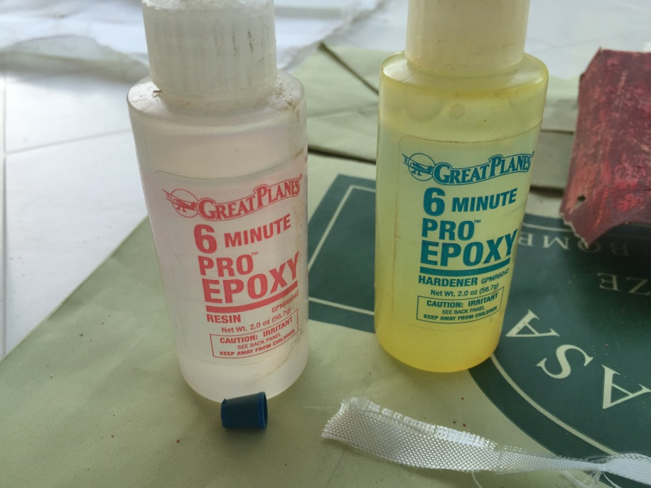
Fig. 6: epoxy resin used to close the antenna

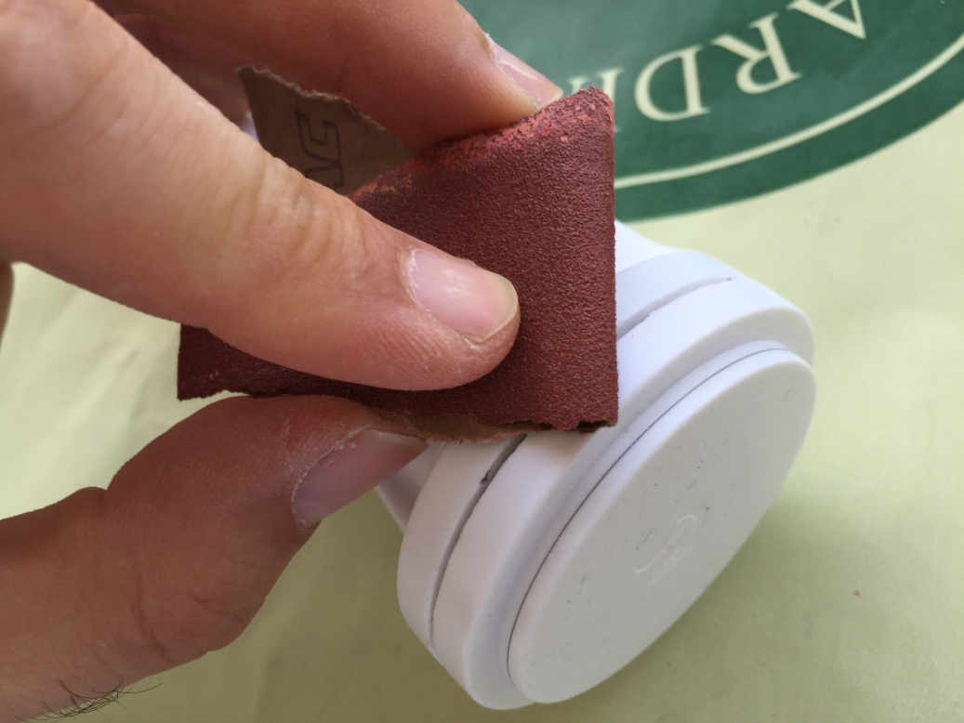
Fig. 7: preparation of the surfaced to be glued

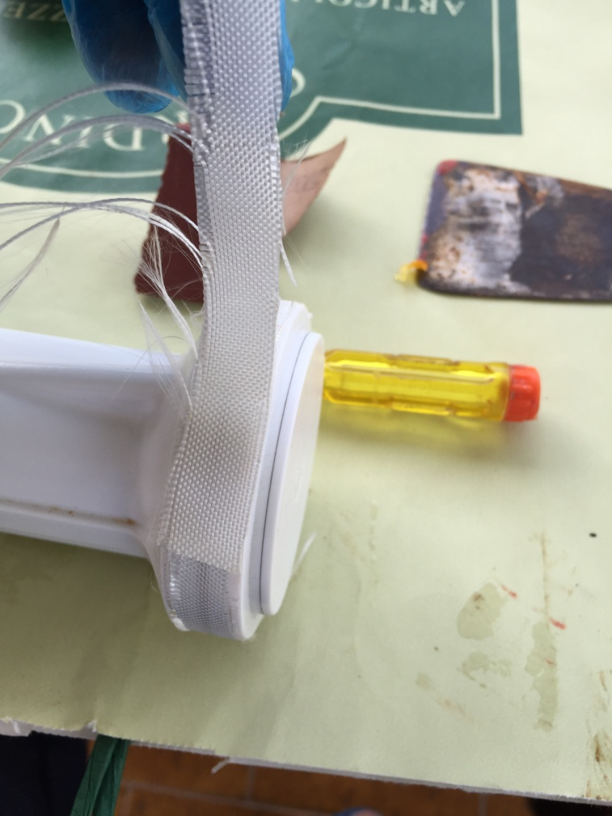
Fig. 8: disposal of fiberglass band

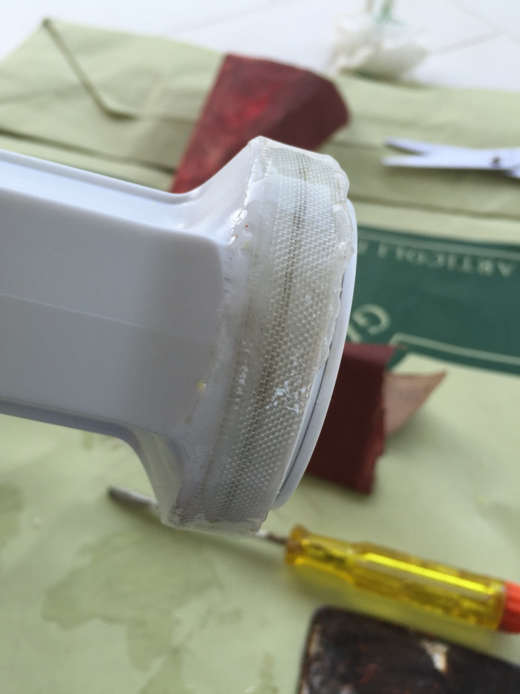
Fig. 9: antenna closed and glued

